

**FACULTY OF INFORMATION TECHNOLOGY**

**SCHOOL RESULTS PROCESSING SYSTEM**

**PROJECT DOCUMENTATION**

**SUBMITTED BY**

**KHISA METRINE NANJALA**

**(REG NO.)**

**Project Proposal submitted in partial fulfillment of the requirements for the award of a Bachelor of Education Technology.**

**Copyright ©2020**

**ACKNOWLEDGEMENT**

It is with the deepest senses gratitude of the almighty that gives strength and ability to complete this project successfully.

First of all, I would like to dedicate my sincere appreciation to my supervisor (Supervisor Name) for allowing me under his supervision. He has given me critics, encouragement, guidance, and valuable advices in order to complete this project. Without his continued support and interest, this project would not have been the same as presented here.

My fellow colleagues should also be recognized for their support and friendship. My deeply thanks also goes to others who have provided assistance at various occasions that invite whether direct or indirectly in the completion of my project.

Last, but not least, my special thanks also extends to my family for the continual encouragement and support.

**TABLE OF CONTENTS**

**LIST OF FIGURES** v

**DECLARATION** vi

**CHAPTER ONE : INTRODUCTION** 1

**1.1** **Introduction** 1

**1.2** **Background Of The study** 2

**1.2.1** **Machakos Boys’ Secondary School Organizational Chart** 3

**1.3** **Problem Statement** 4

**1.3.1** **General** 4

**1.3.2** **Specific** 4

**1.4** **Statement of Objectives** 4

**1.4.1** **General objectives** 4

**1.4.2** **Specific objectives** 4

**1.5** **Justification of the Study** 4

**1.6** **Scope** 6

**1.7** **Limitations** 6

**2** **CHAPTER TWO: LITERATURE REVIEW** 7

**2.1** **Introduction** 7

**2.2** **Theoretical Framework** 7

**2.3** **Analysis of Existing Systems** 10

**2.3.1** **Case study 1: Mwogisoft Executor Exam System** 11

**2.3.2** **Case study 2: E-School System** 11

**3** **CHAPTER THREE: METHODOLOGY** 12

**3.1** **Introduction** 12

**3.2** **Structured Systems Analysis and Design Methodology (SSADM)** 12

**3.2.1** **Techniques** 12

**3.2.2** **Detailed Description of Selected Methodology** 13

**3.2.3** **Comparison of SSADM with Other Models** 14

**3.2.4** **SSADM steps** 15

**3.2.5** **SSADM Structure Breakdown:** 23

**4** **CHAPTER FOUR: SYSTEM ANALYSIS** 24

**4.1** **Feasibility Study** 24

**4.1.1** **Technical feasibility** 24

**4.1.2** **Economic Feasibility** 24

**4.1.3** **Behavioral Feasibility** 25

**4.2** **Requirements Specification** 25

**4.2.1** **Functional requirements** 25

**4.2.2** **Non Functional Requirements** 25

**5** **CHAPTER 5: SYSTEM DESIGN** 26

**5.1** **Use Case Diagram** 26

**5.1.1** **Actor Description** 27

**5.1.2** **Use case description** 27

**5.2** **Data Flow Diagram** 29

**5.2.1** **Context Diagram** 29

**5.2.2** **Level 1 DFD** 30

**5.3** **Entity Relationship Diagram** 31

**5.4** **Sequence Diagram** 32

**5.5** **Process/ program design** 35

**5.5.1** **Admin module** 35

**5.5.2** **Teacher Module** 35

**5.5.3** **Student Module** 35

**5.5.4** **Parent module** 35

**5.6** **Input Design** 35

**5.6.1** **Login form:** 36

**5.6.2** **Dashboard** 36

**5.6.3** **Manage Student** 38

**5.6.4** **Manage Teacher** 39

**5.7** **Output design** 40

**5.7.1** **Student Performance Report** 40

**5.8** **Database Design** 41

**5.8.1 Table: Users** 41

**5.8.2 Table: Students** 42

**5.8.3 Table: Teachers** 42

**5.8.4 Table: Results** 43

**5.8.5 Table: Terms** 43

**5.8.6 Table: Subjects** 44

**5.8.7 Table: Subject Group** 44

**5.8.8 Table: Grades** 44

**5.8.9 Table: Exams** 44

**5.8.10 Table: Scores** 45

**5.8.11 Table: Forms** 45

**5.8.12 Table: Roles** 45

**5.8.13 Table: Role_users** 45

**5.8.14 Table: Streams** 46

**6** **CHAPTER SIX: SYSTEM TESTING AND IMPLEMENTATION** 47

**6.1** **System Testing** 47

**6.1.1** **Unit testing** 47

**6.1.2** **Integration Testing** 48

**6.1.3** **System Testing** 48

**6.1.4** **Acceptance Testing** 48

**6.2** **System Test-Cases** 48

**6.3** **Functional Test-Cases** 49

**7** **CHAPTER SEVEN: CRITICAL APPRAISAL** 52

**7.1** **Challenges** 52

**7.2** **Lessons Learnt** 52

**7.3** **Achievements** 52

**7.4** **Limitations** 52

**8** **CHAPTER 8: CONCLUSION AND RECOMMENDATIONS** 53

**8.1** **Recommendations** 53

**8.2** **Conclusion** 54

**9** **APPENDICES** 55

**9.1** **APPENDIX I** 55

**9.2** **APPENDIX II** 58

**9.3** **APPENDIX III** 59

# **LIST OF FIGURES**

**Figure 1.1 Organizational chart 3**

**Figure 2.1 Illustration Of Open SSL 9**

**Figure 2.2 Architecture of Open SSL 9**

**Figure 3.1 SSADM Breakdown 23**

**Figure 5.1 System Use Case Diagram 26**

**Figure 5.2 Context Diagram 30**

**Figure 5.3 Level 1 DFD 31**

**Figure 5.4 Entity Relationship Diagram 32**

**Figure 5.5 Login Scenario Sequence Diagram 34**

**Figure 5.6 User registration scenario 35**

**Figure 5.7 login Form 37**

**Figure 5.8 Admin Dashboard 38**

**Figure 5.9 Teacher Dashboard 38**

**Figure 5.10 Student Dashboard 39**

**Figure 5.11 Manage Student 40**

**Figure 5.12 Manage Teacher 41**

**Figure 5.14 Student report 43**

# **DECLARATION**

I hereby declare that the work in this project entitled “School Results Processing System” is my own except for quotations and summaries which have been duly acknowledged. The project has not been accepted for any degree and is not concurrently submitted for award of other degree.

Student Signature Supervisor Signature

___________________________ _______________________

Ruth Mwende Supervisor Name

# **CHAPTER ONE: INTRODUCTION**

## **Introduction**

People nowadays are living in an information age dependent upon digital information. Digital information is electronic information, the result of computer processing. Every type of job relies upon getting information to others. Computers enable the efficient processing and storage of information.

A results processing and grading system plays a key role in the management of any school. But, such systems do not often relate expectations, outcomes and performance. As each student desires to achieve a good score fir each assignment, cat, exam, project and or report, the whole process adds heavy workload for teachers in order to make their evaluation fair, comprehensive and accurate. From the academics department perspective, these are necessary to avoid disagreement from students and parents. A computerized results processing system is a highly desirable addition to the school system, particularly when it can provide less effort and a more effective and timely outcome.

Grading systems are designed to provide incentives for achievement and assist in identifying problem areas of a student. It is the most commonly used means of analyzing student performance and skills. Student’s grades are vital information needed in advancing to the next year of level and its accuracy is very important.

Many teachers feel that the time they take in recording and computing for the grades of their students is the time that could be better spent elsewhere, like preparing lessons, researching or meeting with their students. With the advent of computer technology, more and more schools are taking advantage of a variety of grading systems available both offline and online that can help save time on administrative tasks and give teachers more time to attend to other important functions. However, a greater majority, especially small schools, government schools, and schools in remote areas, still utilize the manual method of recording and computing for the grades of the students.

The proponents of this study wish to reduce the workload of teachers by eliminating the need for a manual computation and recording of each grade. The common problems encountered in manual recording and computations are errors, file handling problems and redundancy. As the workload gradually increases with growing amounts of grades and student lists that need to be attended to, it becomes tedious on the teacher to proficiently manage them in time for documentation and file submission to higher education authorities. As such, this paper aims to produce a workable computerized grading system that will address these issues.

## **Background Of The study**

Machakos Boys’ Secondary School is a Kenyan school located in Rift Valley Province, Nandi County, and Emgwen constituency. It was established in the year 1925 and is utilizing the manual system in almost all phases of school work.

The school maintains a small staff of teachers and personnel compared to the rapid growing population. There are teachers handling as much as four different subjects, aside from being a class teacher or head of department. Majority of the teacher teach in at least three of the four classes i.e. Form 1, Form 2, Form 3 and Form 4.

Machakos Boys’ Secondary School uses the manual way of computing grades and adding information or records of both teachers and students. The process entails a lot of effort and by computing and storing of data, the process is prone to error especially for the teachers who handle two or more classes. By using the manual way of computing and storing data, being prone to errors is possible and just by a single mistake, repeating the process may be required.

Developing an online results processing system for Machakos Boys’ Secondary School would make the task of recording and computing grades easier for the teachers. This will not only benefit the teachers of the school but will also benefit the students because of the improvement in the accuracy of calculations and in the proficiency and productivity of the teachers. Parents and students will also benefit largely as they will be able to access their grades online from any location in the world.

### **Machakos Boys’ Secondary School Organizational Chart**

BOG

PTA

PRINCIPAL

D.PRINCIPAL ACADEMICS

D.PRINCIPAL ACADEMICS

HOD ENGLISH

HOD SCIENCES

HOD HUMANITIES

HOD G & COUNSELING

HOD BOARDING

HOD FINANCE

HOD CREATIVE ARTS

HOD KISWAHILI

HOD DISCIPLINARY

**Figure 1.1 Organizational chart**

## **Problem Statement**

### **General**

The manual preparation, submission and distribution of students’ grades of Machakos Boys’ Secondary School.

### **Specific**

* To create an online portal that will allow teachers to submit student grades
* To develop a system that will enable online student registration
* To develop a system that automatically computes and analyzes student grades
* To develop a system that allows parents and students to view grades online
* To reduce the number of errors encountered in the current manual system.

## **Statement of Objectives**

### **General objectives**

To develop an online results processing and grading system for Machakos Boys’ Secondary School.

### **Specific objectives**

* To develop an online system that automates the process of processing student examination results
* To develop a secure system that allows students, parents and teachers to access exam results online.
* To develop a system that stores students results for a long period of time using persistent storage.
* To develop a system that generates and prints reports summaries of individual students and overall class performance.

## **Justification of the Study**

The computers provide convenience to its users through the easier and faster way of recording information. The population of students in almost all schools in Kenya is rapidly increasing thus there is demand for teaching staff is rising.

The online results processing and grading system is a very important aspect of school operations and goals. The students are graded to measure their performance and knowledge in every grading period. Teachers spend massive time to accurately compute the grades of the students using their calculators and in earlier times, teachers manually solved problems using pen and paper.

The basic objective of an online results processing and grading system is to automate the processes of preparing students grades and making them available to both the student and their parents. The parent is able to periodically monitor the students’ performance over time.

An online results processing and grading system for Machakos Boys’ Secondary School will provide a marked improvement in the way teachers’ record and compute for grades of students. The study will be a great help to the following:

* **Teachers**

Teachers will be able to record and compute the grades of their students faster and therefore reducing their workload and providing them with added time to attend to other important activities. This in turn will improve their efficiency as teachers.

* **Students**

The system will improve student’s accessibility to their grades once they are released. Since the system is responsive, it can be accesses via mobile phone. If a student has any complain concerning their grades, they can use the same system to address the problem to the specific teacher concerned.

* **Parents**

Parents are a great beneficiary since they won’t have to travel to school to follow up their student performance. They can log onto the parent portal to view their son’s progress. Thus this improves convenience and saves them the cost of travelling to the school

* **School Administration**

The school administration will largely benefit in reduction on the cost of buying materials used in preparing the examination.

## **Scope**

The project undertakes to develop a student online results processing system which will be used to do the following:

* Can register a student into the system
* Record student grades
* Can print student report forms
* Enable parents to access student reports online

## **Limitations**

Despite of the good capabilities of the system, any system can have limitation. The system shall ha eth following limitations

* The system cannot be accessed offline i.e. There is need for internet connectivity
* If the teacher submitted wrong grades but within the required range i.e. 0-100, the online system has no capability of handling human error.
* The user’s browser must have JavaScript enabled for the system to run effectively.

# **CHAPTER TWO: LITERATURE REVIEW**

## **Introduction**

This chapter states the different literature and studies that were conducted for the researcher to gain familiarity with literature that are relevant and similar to the present study.

## **Theoretical Framework**

Theoretically, the main purpose of the project is to create an online results processing and grading system for Machakos Boys’ Secondary School.

There is a growing body of research focused on developing better ways to manage school examination results. Some of these researches focused on various objectives that are to be achieved by the system.

Grading is one of the most fundamental facets of Kenyan education. In thousands of Kenyan schools, grading is accepted as part of schooling. It is as natural as the arrangement of students on the desks of the presence of a teacher in a class room. It is a part of what David Tyack and Larry Cuban have called the ‘grammar of schooling’ (1995). From the primary school up through advanced graduate programs, instructors/teachers spend hours each week marking papers and exams, students wring their hands over grades and steal glances at each other’s scores, and parents express various levels of anxiety about the marks their children are earning. Grades have become such an important feature of the modern schools. Grades have lasting and profound consequences: once earned, they serve as a key determinant of future success - a mechanism through which schools, universities, and employers judge individual academic achievement.

A paper proposed on web based online examination and grading system (Rashad et al, 2010). The system manages examination and auto-grading of exam results. It further facilitates conducting exams, collection of answers, auto marking the submissions and production of reports for the test. It provides support for different kinds of questions. The system can be used for both local and remote examination. It could assist teachers and examiners who are willing to create new exams or edit existing ones as well as students participating in the exams. It was built using various open source technologies AJAX, PHP, HTML and MYSQL database are used in this system. An auto-grading module was generalized to enable different exam and question types. The system was tested in the Mansoura university quality assurance center. The test proved the validity of using this kind of web based systems to evaluate students in the institutions with high number of students. The proposed results processing system borrows some ideas from this system. The system is expected to have auto-grading and reporting features which are implemented in the system. In addition to this, the system will also add functionality to produce more analysis reports which will generate statistical reports comprising pie charts and graphs.

In 2006 J. Castella Roca, J. Herrera Joan Comarti and A. Dorca Josa introduced a secure e-exam and e-grading management system, containing three kinds of participants: students, teachers and a manager. Manager is an authority that is responsible for the whole process, manages questions, answers, grades. Manager is assumed to be honest, so the scheme is based on a Trusted Third Party.

Security is very important for any system that deals with data. Unfortunately, if security is not well implemented, it may cause some overheads to the system or lead to unsatisfied clients. Therefore, the proposed system will ensure restricted access is implemented only where it is applicable. Instead of having a third party who is expected to be honest, the system will do all the filtering, authentication, authorization and encryption. The major idea borrowed from this system is security. An examination results processing system must be secure. Therefore, Open SSL will be used to ensure security. Open SSL is an open source implementation of SSL (Secure Socket Layer) protocol. It is written in C language to implement basic cryptographic protocols. Open SSL is very secure and free to implement. Passwords and sensitive information transmitted over the network will also be encrypted to secure the system information. The data is encrypted even before it leaves your computer, and is decrypted only once it reaches the destination computer. Open SSL uses an abstraction library called BIO to handle communication of various kinds, including files and sockets, both secure and not.

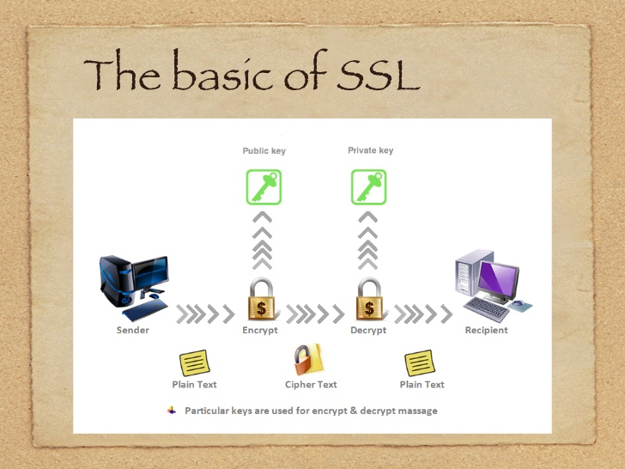

**Figure 2.1 Illustration of Open SSL**

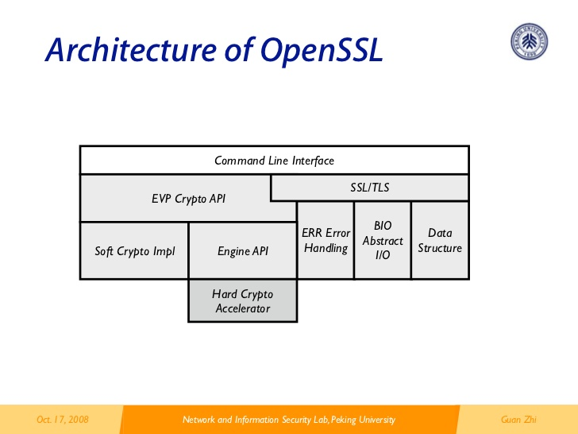

**Figure 2.2 Architecture of Open SSL**

After studying some of the existing systems, it was discovered that most of them include results management module as part of the larger system. Therefore, most of the systems would be referred to as online exam management system or school management system both of which comprise the result management section as part of the system. Having the results management system as part of the larger system makes less efficient as the chances of the results management system getting attention on issues such as security and smooth interaction among concerned parties may be difficult. Implementing the results processing system as a separate module is a better alternative since it would be easy to concentrate on that single system and realize great capabilities of the system. Despite the system being developed separately, it can still integrate with existing systems such as the student registration system.

This literature review also introduces and defines concepts relating to cryptography, cryptographic protocols, issues relating to cryptography and the development of software frameworks. Cryptography is the discipline, art and science of ensuring that messages are secure from possible attacks, whether these attacks be eavesdropping, impersonation or corruption. Cryptography provides security through a number of mathematical transformations that can be proven to be mathematically secure provided some optimum conditions (Schneier, 1996). We however need to cognizant that cryptography on its own is insufficient to ensure a high level of security within an organization, that is to say that cryptography is not the silver bullet to solve all information security issues and should be used in conjunction with good security practices (B. Schneier, 1999).

## **Analysis of Existing Systems**

In Kenya, a number of secondary schools have adopted the use of electronic results management system. One system currently popular is the Roland Exam Software. The system is an offline system created using Visual Basic. It allows the teacher register new students, submit student scores and also generate report forms. Only teachers can access the system since it is offline, therefore for a student or student’s parent to access their scores, they have to visit the school physically.

Another existing system is Results Management System from India. The System provides Student online/offline database, Student Results view/printing in case of online portal and archives of student results from lowest to highest academic levels which can be accessed even after graduation. The proposed system will implement a system that supports only one level of education i.e. secondary school because after leaving high school, students are enrolled to colleges of their choices. Therefore, it is almost impossible to keep track of their performance.

### **Case study 1: Mwogisoft Executor Exam System**

Mwogisoft Executor Exam System is an exam result management system used in a number of secondary schools in Kenya. It’s a desktop application that has only one set of users i.e. teachers. It has auto-grading capability and students can only access the results after all the corrections on printed draft copies are made. The results are then made available on the notice board. The limitation of this system is that it only works offline. Therefore a student is given a printed report form which they are expected to deliver to their parents. There is no way to follow up to ensure it is the exact same report form that’s delivered to parents. An example of a school that uses the Mwogisoft Executor Exam System is Machakos Boys’ Secondary School. The proposed system ensures that the parents are able to follow up their student’s academic progress by sending them an email once the results are released and also by providing an online portal for parent access to the system.

### **Case study 2: E-School System**

Based on case study 1, e-School system is a system that was developed by a group of Bangkel II students from UTEM, 2006 session. This system was used by schools via the intranet. The main purpose of the system is to centralize all information. With this, the administrator, teachers and students will be able to access the required information at any time and place.

E-School system has four main functions which are: determine class, calculate mark for examination result, student information and also scholarship information. This system is also able to produce reports and view the statistics. E-School system has been developed using PHP 5, MySQL an Apache web server. The main weakness of the system is that I does not provide the functionality of the administrator to add subjects and classes. Besides that, E-School System is also not user friendly.

# **CHAPTER THREE: METHODOLOGY**

## **Introduction**

There are various approaches to system development which are used on Information System Projects. These approaches are formally termed as “Lifecycle models”. Various models exist many of which are developments or refinements of earlier ones. These models are

1. Spiral Model
2. Rapid Application Development( RAD)
3. Unified Software Development Process (USDP)
4. Waterfall model
5. Structured Systems Analysis and Design Methodology (SSADM)

In this project, Structured Systems Analysis and Design Methodology (SSADM) was used in the modelling of the system.

## **Structured Systems Analysis and Design Methodology (SSADM)**

SSADM (Structured Systems Analysis and Design Methodology) is a methodology. It is a system of ways of doing things especially regular and orderly procedures, used in the analysis and design stages of systems development.

SSADM is used by other companies because they expect the use of a disciplined engineering approach will eventually improve the quality of the systems they produce. Many companies have been willing to incur the considerable expense of implementing SSADM (e.g. staff training) with this expectation in mind.

SSADM revolves around the use of three key techniques namely, Logical Data Modelling, Data Flow Modelling and Entity/Event Modelling.

### **Techniques**

The 3 most important techniques that are used in SSADM are:

**Logical Data Modelling**.

This is the process of identifying, modelling and documenting the data requirements of the system being designed. The data are separated into entities (things about which a business needs to record information) and relationships (the associations between the entities).

**Data Flow Modelling**.

This is the process of identifying, modelling and documenting how data moves around an information system. Data Flow Modeling examines processes (activities that transform data from one form to another), data stores (the holding areas for data), external entities (what sends data into a system or receives data from a system), and data flows (routes by which data can flow).

**Entity Behavior Modelling**.

This is the process of identifying, modelling and documenting the events that affect each entity and the sequence in which these events.

### **Detailed Description of Selected Methodology**

After researching on different methodologies and evaluating them I finally settled on applying Structured System Analysis and Design Methodology (SSADM) for my system.

The reason behind this is that it is data driven and models logical and physical views of the system, that is, it utilizes differing views of the system. It requires user involvement and uses both top-down and bottom-up techniques as well as diagrammatic and non-diagrammatic techniques. SSADM Links to quality assurance, project management, risk assessment and other project procedures

Its main purpose is to:

* Improve project management & control
* Make more effective use of experienced and inexperienced development staff
* Develop better quality systems and Make projects resilient to the loss of staff
* Enable projects to be supported by computer-based tools such as computer-aided software engineering systems
* Establish a framework for good communications between participants in a project
* SSADM can reduce the chances of initial requirements being mis-understood and of the systems functionality straying from the requirements through the use of inadequate analysis and design techniques

**Reasons Why SSADM is a Better Option (Strengths of SSADM)**

* Good for large and complex projects because it has a clear structure
* Customer Evaluation allows for any changes deemed necessary, or would allow for new technological advances to be used
* Allows customer and developer to determine and to react to risks since users are mostly involved in the development process.
* Eliminates cases of rejection of the final system since it is user-oriented.
* Ensures quality system analysis and design, therefore creating a big chance of developing a quality system.
* The client is given details at the end of each stage.
* The methodology is well established
* It provides a precise and well-defined documentation therefore improved understanding.

**Weaknesses:**

* It gives a single end-product which hopefully meets the user requirements.
* It is expensive for small projects.
* If the developer only concentrates in the methodology approach and uses excess time doing analysis and design, the final implementation may never be completed when required.
* The methodology does not include some important phases in systems development which include Implementation, maintenance and testing.

### **Comparison of SSADM with Other Models**

#### **Comparison of Waterfall based Waterfall and SSADM.**

SSADM has the following advantages:

* Risks can be identified and can be dealt with sooner
* Changes can be managed better
* A higher degree of reuse of Software is possible since the design is well done and documented.
* During the Project, Project team can understand the requirements better
* Total quality of the product is higher
* There is user-driven development.

#### **Comparison of SSADM and RAD (rapid application development)**

* Unlike rapid application development, which conducts steps in parallel, SSADM builds each step on the work that was prescribed in the previous step with no deviation from the model. Because of the rigid structure of the methodology, SSADM is praised for its control over projects and its ability to develop better quality systems.
* SSADM covers those aspects of the life-cycle of a system from the feasibility study stage to the production of a physical design; it is generally used in conjunction with other methods, such as PRINCE, which is concerned with the broader aspects of project management. RAD covers all the aspects of life-cycle of a system

### **SSADM steps**

SSADM contains five modules and seven stages. The modules and stages applied in developing the system using the Structured System Analysis and Design methodology are discussed below.

#### **Module 1: Feasibility Study**

**Stage 0: Feasibility study**

This is the initial investigation which involves a brief study of the problem to determine whether or not the project should be carried out.

The feasibility study will ensure that the project is viable technically, and operational. The feasibility will assist the researcher to assess the scope of the project and define the problem. The feasibility study will also be used to select the most viable option. The findings of the feasibility will be used to prepare the feasibility report. There are three main types of feasibility studies as outlined below.

**Economic feasibility study (EFS)**

This should demonstrate the net benefit of the proposed application in light of the benefits and costs .EFS weighs a host of options, or simply determines if a venture makes long-term economic sense.

It will helps the management of the institution to weigh their options by carefully examining the available alternatives for a project, identifying risk factors, gathering credible economic intelligence, and by using quantitative analysis, fact-based research, and/or survey methodology to support theories and findings.

**Technical feasibility study**

This involves questions such as whether the technology needed for the system exists, how difficult it will be to build, and whether the firm has enough experience using that technology. The assessment is based on an outline design of system requirements in terms of Input, Output, Fields, Programs, and Procedures

**Operational** **feasibility study**

This involves defining the urgency of the problem and the acceptability of any solution. If the system is developed, will it be used? Includes people-oriented and social issues: internal issues, such as manpower problems, labor objections, manager resistance, organizational conflicts and policies; also external issues, including social acceptability, legal aspects and government regulations.

Conducting interviews with the staff in the school as well as making observations will achieve the above tasks. The tasks will also be achieved by the use of a high level Data Flow Diagram (DFD).

The findings of the feasibility will be used to prepare the feasibility report.

The net result will be a decision for whether to proceed with the project, and this is done by looking at the following:

1. **Nature of the problem**: Begin to determine the nature of the problem. Sometimes what appears to be the problems turn out to be, on a closer look, only a symptom?
2. **Scope of the project:** Establishing the scope of the project is critical. Sometimes problems tend to expand if no firm boundaries are established.
3. **Objectives of the project:** The system analyst examines what the system should be able to do.

This is expressed as objectives.

The steps that will be followed to achieve the objectives of this module are as follows.

* 1. Prepare for feasibility.
  2. Define the problem.
  3. Select the feasibility study options
  4. Prepare a feasibility study report.

**Deliverable:** Feasibility study report.

The feasibility study report will contain the following.

* + current services description
  + The problems in the current system
  + The methods of fact finding used
  + Details if future requirements
  + Explanation of the proposed system
  + The options that were suggested
  + Financial statement of the costs and benefits of the proposed system
  + Recommendations.

#### **Module 2: Requirements Analysis**

The best way to understand a system is to gather all the data that you can about it. This data must then be organized and analyzed. During the system analysis phase, one is concerned with data gathering and data analysis. Most commonly used sources of data gathering are interviews, written documents, observation and sampling. Sometimes one is required to use all the resources but in some cases it will be appropriate to use some and not others.

On the other hand data analysis, which involves the organization of collected data, usually adopts the use of two tools which are data flow diagrams (DFDs) and entity diagrams. An entity may be regarded as an object which is of interest to the organization.

The purpose of gathering and organizing data is twofold: to understand the system and, as a by-product of that understanding, to establish the system requirements. Requirements may be equated to a statement by the customer of what the system shall achieve in order to meet the customer’s needs. These involve both functional and non-functional requirements.

This module consists of two stages.

**Stage 1: Investigation of Current Environment**

This will involve a detailed investigation of the current environment at the institution, which includes current requirements of the institution and the existing Results management System. The task will be achieved by interviewing the school members of staff who are likely to be affected by the system. Questionnaires will also be administered on this population. An examination of the feasibility report will be undertaken and a thorough study of the present processes and data undertaken. A mapping of the present physical data flow model with a logical data flow model will be done. Process entity relationship matrices will also be used. Business Activity modelling, Data flow modelling and Logical Data modelling will be used.

The steps that will be used are:

* 1. Develop a business activity Model
  2. Investigate and define the requirements
  3. Investigate the current processing
  4. Investigate the current data
  5. Derive the logical view of the current services.
  6. Assemble investigation results

**Deliverable:** A detailed description of the current environment.

**Stage 2: Business Systems Options**

Here the project will aim at determining the functionality of the new system, giving a cost justification of the user requirements and outlining several business systems options meeting the minimum user requirements. A presentation of the business options will be made to the management at the institution. A development of entity relation models will be undertaken.

The tasks will be achieved by using standard financial appraisal methods at the same time give consideration of the soft issues that will have been picked from the feasibility study.

The following steps are part of this stage:

* Define BSOs. (Business Systems Options) This step is concerned with identifying a number of possible system solutions that meet the defined requirements from which the users can select.
* Select BSO. This step is concerned with the presentation of the BSOs to users and the selection of the preferred option. The selected option defines the boundary of the system to be developed in the subsequent stages.

The tasks will be achieved by using standard financial appraisal methods at the same time give consideration of the soft issues that will have been picked from the feasibility study.

**Deliverables:** Detailed Requirements Specification, Data catalogue, logical data modeling, Data Flow Diagrams (DFDs), Entity Relationship Diagrams and Entity Life Histories (ELH).

**Stage 3: Requirements Specification**

This will involve the design of the required system, updating of the requirements catalogue, extension of the entity model and definition of the users roles in the new system. The documentation forms for all entities and attributes will be completed and a definition of inputs, processes and outputs of each function done. Finally there will be a verification of the objectives and functions.

The above tasks will be achieved by using Entity Life Histories and Entity Relationship Diagrams.

The following steps are part of this stage:

* Define required system processing. This step is to amend the requirements to reflect the selected Business System Option, to describe the required system in terms of system data flows and to define the user roles within the new system.
* Develop required data model. This step is undertaken in parallel with the above step. The **LDM** of the current environment is extended to support all the processing in the selected business system option.
* Derive system functions. During the parallel definition of data and processing, additional events are identified, which cause existing functions to be updated, and new functions to be defined. Service level requirements for each function are also identified in this step.
* Develop user job specifications. A Work Practice Model is developed to document the understanding of the user jobs in concern.
* Enhance required data model. Its objective is to improve the quality of the required system LDM by the application of relational data analysis (also known as normalization).
* Develop specification prototypes. It is used to describe selected parts of the required system in an animated form, for demonstration to the users. The purpose is to demonstrate that the requirements have been properly understood and to establish additional requirements concerning the style of the user interface.
* Develop processing specification. This step is principally concerned with defining the detailed update and enquiry processing for the required system.
* Confirm system objectives. During stage 1 and 3, the requirements will have been recorded, as they are identified, in the user requirements. This step represents the final review of the requirements before the completion of the Definition of Requirements Stage.

The Deliverable will be the systems design for the new system.

**Stage 4: Technical Systems Options**

At this point the operating environment in terms of the hardware and software configuration will be determined. The development strategy and the functionality and impact of the system on the organization will be determined.

The tasks will be achieved by identifying the resource constraints. A review of the performance, security and service level requirements will also be conducted.

The following steps are followed to achieve the objective of this phase:

* + Define the technical system options
  + Select the technical system option

**Deliverable:** selected technical system option which includes the technical specifications.

**Stage 5: Logical Design**

This will involve a statement of what the system is required to do. It will also require the definition of the dialogue and menu structures, update processes, operations, processing enquiries and controls. There will also be a definition of the application of the system.

The task will be achieved by using Entity Relationship Modelling and Entity Life Histories.

The following activities are part of this stage

* **Define user dialogue.** This step defines the structure of each dialogue required to support the on-line functions and identifies the navigation requirements, both within the dialogue and between dialogues.
* **Define update processes.** This is to complete the specification of the database updating required for each event and to define the error handling for each event.
* **Define enquiry processes.** This is to complete the specification of the database enquiry processing and to define the error handling for each enquiry.

The deliverable will be a detailed logical design.

**Stage 6: Physical Design**

A mapping of the logical design to the specific physical environment will be done. The roles of the technologist, programmer and the database designer will be defined. It will be verified that the final design satisfies the user requirements.

The following activities are part of this stage:

* Prepare for physical design and Plan the approach
* Learn the rules of the implementation environment
* Review the precise requirements for logical to physical mapping
* Complete the specification of functions
* Incrementally and repeatedly develop the data and process designs

**Deliverables:** physical design which will be done using:

### **SSADM Structure Breakdown:**

The figure below illustrates the breakdown of the lifecycle into hierarchy of modules, stages, steps and tasks.



**Figure 3.1 SSADM Breakdown**

# **CHAPTER FOUR: SYSTEM ANALYSIS**

In this chapter, we look at feasibility study followed by the functional and non-functional requirements of the system which will be described and modelled using UML models.

## **Feasibility Study**

A procedure that identifies, describes and evaluates candidate systems and selects the best system for the job is known as feasibility study.

Three key considerations are involved in the feasibility analysis:

1. Technical feasibility
2. Economic feasibility
3. Operational feasibility

### **Technical feasibility**

The use of PHP, HTML, CSS and java script makes the system development easy and convenient. The system will be able to run on almost any system with minimum requirements. These systems range from smart phones to high end computers.

It reduces data entry errors. Because of data entry validation, it can be easily handled by any user, and it also helps in faster data updates. Also the project though developed with a Graphical User interface, it is easy to manage and operate.

Hence, the project is considered to be technically feasible.

### **Economic Feasibility**

Cost benefit analysis is very important in deciding whether the project is economically feasible or not. It is alone sufficient to save our time and money. It is a onetime investment and does not require regular maintenance. Through cost benefit analysis it was concluded that benefits outweigh costs and thus the project is economically feasible.

### **Behavioral Feasibility**

Behavioral feasibility determines how much effort will go into educating, selling and training the user staff on a candidate system. The project was also evaluated to be behaviorally feasible as it is user friendly and hardly needs extra efforts to educate user for its utility and functioning.

## **Requirements Specification**

### **Functional requirements**

The functional requirements of the system include:

* Register students, teachers and parents
* Provide a platform for computerized submission of student results
* Enable users to access results of students
* Generate student report forms

### **Non Functional Requirements**

Security requirements are important factors in this system as classified data will be stored in the database. User validation will be done during login to insure that the user is valid and that the user only has access to data that they are permitted to access.

The system will have consistent interface formats and button sets for all forms in the application. It will have a form based interface for all data entry and viewing formats, and will generate reports that are formatted in a table and that should look like the existing manual report formats for user friendliness.

The system will be easily maintained by the developer or other authorized trained person and it shall respond as fast as possible in generating reports.

# **CHAPTER 5: SYSTEM DESIGN**

## **Use Case Diagram**



**Figure 5.1 System Use Case Diagram**

### **Actor Description**

**Name:** Admin

**Description:** This is the administrator of the system. The admin has all the privileges to perform all actions on the system. The admin can add or remove users, manage school settings etc.

**Name:** Teacher

**Description:** A teacher is also a user of the system whose role is to submit and manage student scores.

**Name:** Student

**Description:** The student’s role in the system is to view their respective results.

**Name:** Parent

**Description:** The parent is a user who can access the results of the son/daughter online.

### **Use case description**

**Name:** Login

**Actors:** Admin, Teacher, Student, Parent

**Description:** To authenticate a user before the gain access to the system.

**Pre-condition:** The user must be a registered user of the system.

**Flow of events**

1. The user visits the system and the login screen is displayed
2. The user enters their login credentials.
3. The system verifies the submitted details with the database.
4. If the credentials are correct, the user is redirected to the dashboard according to the access level of the student.
5. Use case ends

**Post-condition:**  User logged in

**Name:**  Register user

**Actors:** Admin

**Description:** Add users to the system. The user can be a student, teacher or a parent

**Pre-condition:** The user must be logged in as Administrator.

**Flow of events:**

1. The administrator wants to add a user.
2. The admin switches to the expected section of the system according to the user the want to add e.g. “manage teacher” if they want to add the teacher.
3. Switch to the tab called “Register teacher” if in the teacher section.
4. Fill in all the teacher details and click the register button.
5. System acknowledges that the user has been registered.
6. Use case ends

**Post-condition:** User registered

**Alternative flow of Events**

**Alternative A:** User not logged in as admin

**A1:** User redirected to dashboard.

**A2:** Use case ends.

**Name: Submit Score**

**Actors:** Admin, Teacher

**Description:** To submit student scores

**Flow of events:**

1. The user wants to submit student details.
2. The user clicks on manage grades, then submit score
3. Select either individual or entire class
4. Enter the details and click submit
5. System acknowledges that the score has been submitted.
6. Use case ends

## **Data Flow Diagram**

### **Context Diagram**

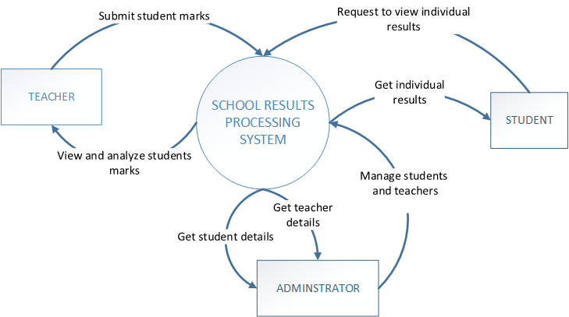

**Figure 5.2 Context Diagram**

### **Level 1 DFD**

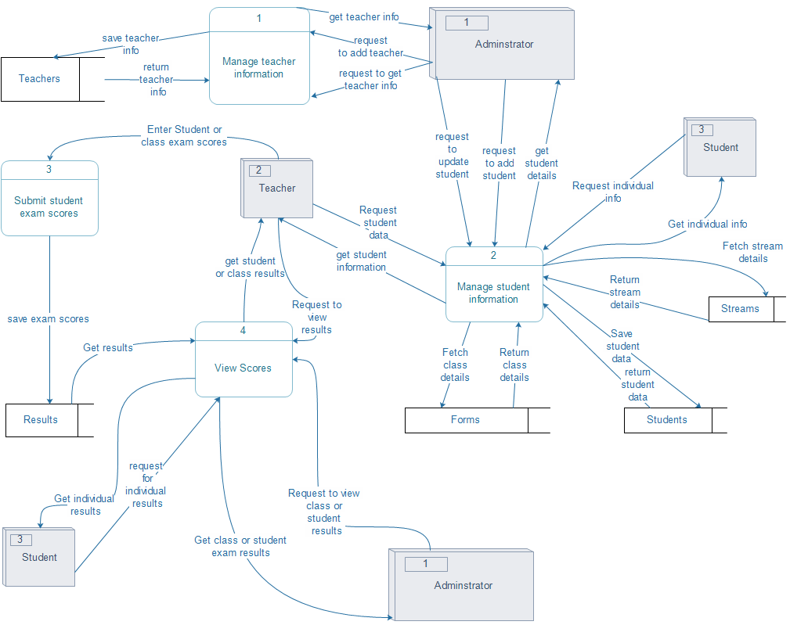

**Figure 5.3 Level 1 DFD**

## **Entity Relationship Diagram**



**Figure 5.4 Entity Relationship Diagram**

## **Sequence Diagram**

Sequence diagrams show the interaction between participating objects in a given use case. They are helpful in identifying the missing objects that are not identified in the analysis object model. To see the interaction between objects, the following describe the sequence diagram for each identified use case.



**Figure 5.5 Login Scenario Sequence Diagram**



**Figure 5.6 User registration scenario**

## **Process/ program design**

Process design refers to the design of the important processes in the system ranging from the functional description of each task to the entire system being considered as a process. The School Results Processing System has been divided into several modules. Each module is bound to have its own specific functions .Each of these modules can described below:

### **Admin module**

This Module mainly deals with the major and sensitive parts of the system. These sections include; student management, teacher management, parent management, school settings, system backup and restore etc. The administrator is the only user who has access to this module

### **Teacher Module**

The teacher module deals with management of student scores and student management. The teachers are the only users who can use this module.

### **Student Module**

This is a limited module that deals with access to student results and student details. Students can use this module to get access to their respective results. This is the only module that students have access to.

### **Parent module**

This is another limited module that allows registered student parents to gain access to their respective student results.

## **Input Design**

Input design is the process of converting user-originated inputs to a computer based formats. Input data are collected and organized into groups of similar data. Once identified, appropriate data are selected for processing the input forms are designed using GUI controls so that errors may be avoided. The inputs are:

### **Login form:**

This form is used by the administrator, teacher, student and parent to login to the system using username and password. Thus it provides security to the system. It also has the provision to change the password of the user who has currently logged in. The screenshot below shows the login screen of the system.

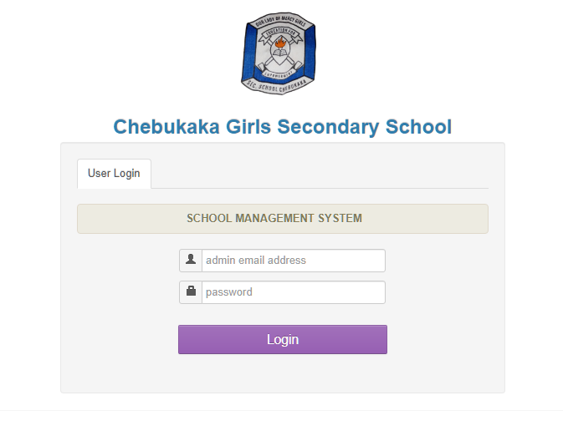

**Figure 5.7 login Form**

### **Dashboard**

This page displays all the activities that can be done by different users. Different users have different dashboards according to their access levels. There are 4 different dashboard i.e. Administrator, Teacher, Student and parent dashboard.

#### **Administrator Dashboard**

The screenshot below shows the administrator dashboard. The administrator has all the restricted capabilities.

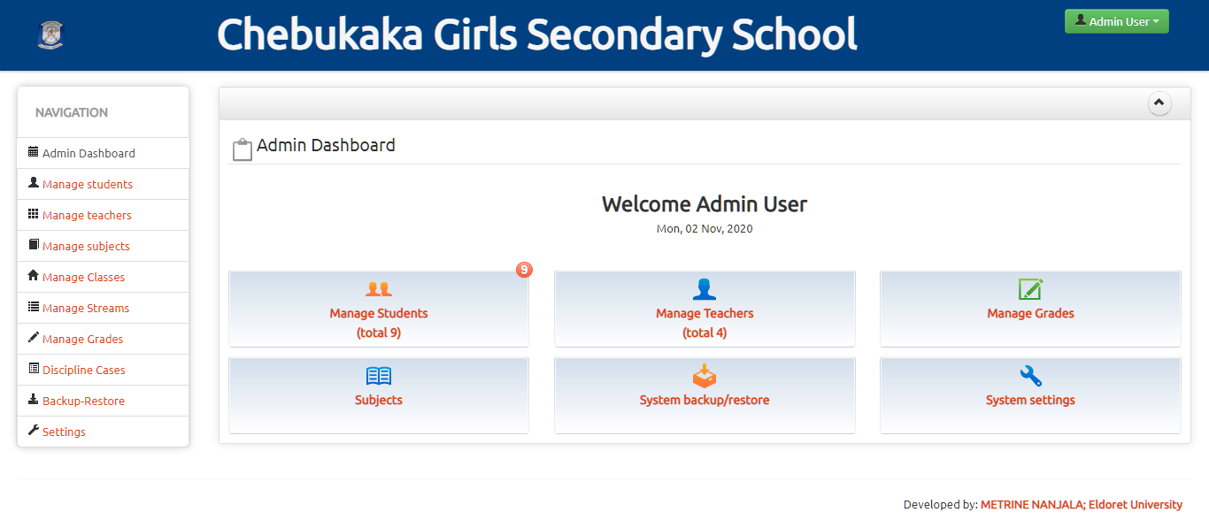

**Figure 5.8 Admin Dashboard**

#### **Teacher Dashboard**

The screenshot below displays the dashboard of a teacher and all the activities they can perform.

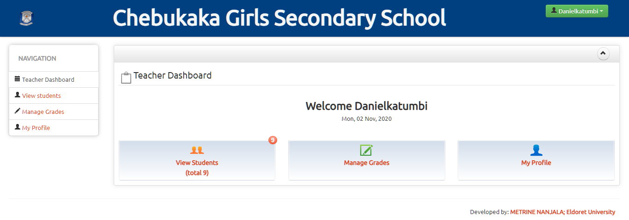

**Figure 5.9 Teacher Dashboard**

#### **Student dashboard**

The screenshot below shows the student dashboard.

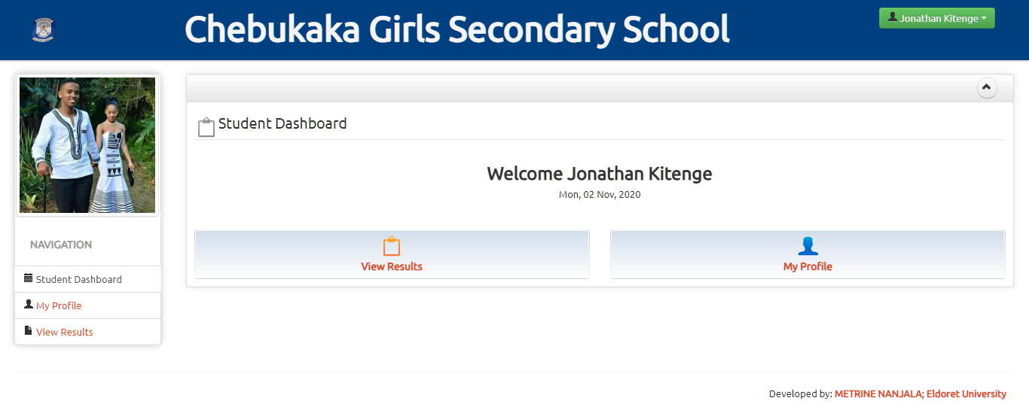

**Figure 5.10 Student Dashboard**

### **Manage Student**

This page allows the administrator to register, edit student details, search a student and also access their details.

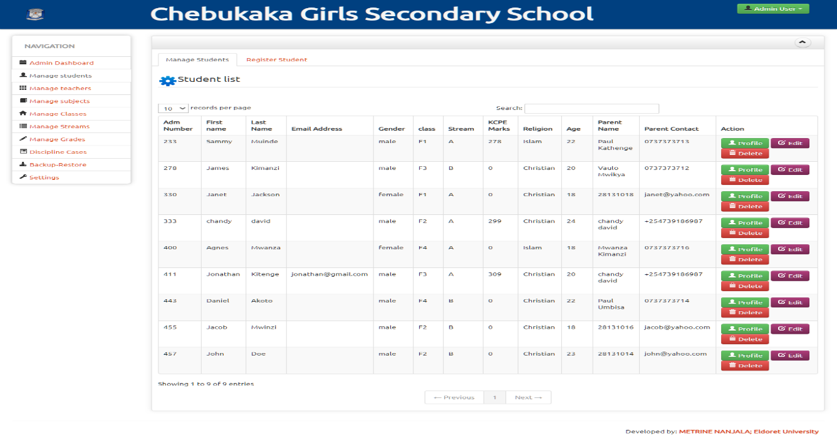

**Figure 5.11 Manage Student**

### **Manage Teacher**

This page allows the administrator to register, edit teacher details, search a student and also access their details.

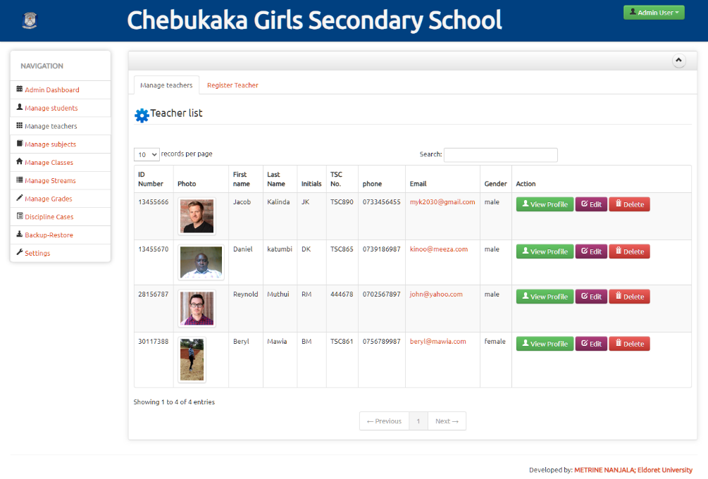

**Figure 5.12 Manage Teacher**

## **Output design**

The output design phase is another very important feature of a system. The outputs are mainly used to communicate with user, processing the input data given by the user etc. It is documented in each stage of the project to ensure error free output. Output screens are designed in very simple and understandable format .The main outputs are:

### **Student Performance Report**

The student performance report displays the summary of the performance of a student. It displays all the subjects and scores that meet the specified criteria such as year, term, class and exam. The report displays the student details and the totals and position.

The screenshot below shows a sample report for a student.

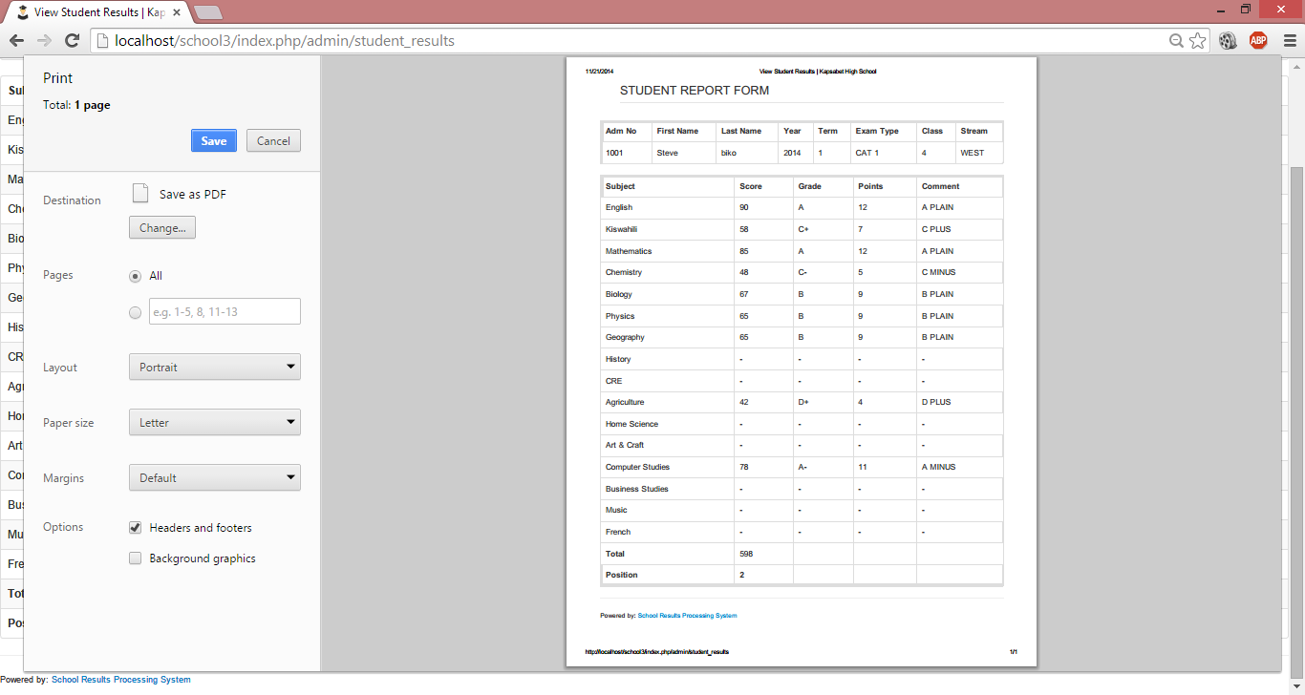

Figure 5.14 Student report

## **Database Design**

### **5.8.1 Table: Users**

|  |  |  |  |
| --- | --- | --- | --- |
| **COLUMN** | **DATATYPE** | **SIZE** | **DESCRIPTION** |
| Id | Int | 10 | User’s id |
| Name | Varchar | 191 | User’s name |
| Initials | Varchar | 191 | User initials |
| Email | Varchar | 191 | User’s email |
| Photo | Varchar | 191 | User profile picture. |
| Password | varchar | 191 | User’s password |
| Last_login | timestamp |  | Last time the user logged in. |

### **5.8.2 Table: Students**

|  |  |  |  |
| --- | --- | --- | --- |
| **COLUMN** | **DATATYPE** | **SIZE** | **DESCRIPTION** |
| Id | Int | 10 | ID |
| Adm_no | Int | 10 | Admission number |
| Fname | varchar | 191 | Full Name |
| Dob | varchar | 191 | Date of Birth |
| Gender | varchar | 191 | Gender |
| Religion | varchar | 191 | Religion |
| form_id | int | 10 | References ID on the forms table |
| Stream_id | int | 10 | References ID on the streams table. |
| Parent_name | varchar | 191 | Name of Parent |
| Parent_contact | varchar | 191 | Parent’s contact details |
| Photo | varchar | 191 | Student’s profile picture. |

### **5.8.3 Table: Teachers**

|  |  |  |  |
| --- | --- | --- | --- |
| **COLUMN** | **DATATYPE** | **SIZE** | **DESCRIPTION** |
| Id | int | 10 | ID |
| User_id | int | 10 | References ID on the users table. |
| id_no | int | 10 | National ID number of the teacher. |
| Name | varchar | 191 | Full name of the teacher |
| Initials | varchar | 191 | Teacher initials. |
| Tsc | varchar | 191 | Teacher’s TSC number |
| Dob | varchar | 191 | Date Of Birth |
| Gender | varchar | 191 | Teacher’s Gender |
| Religion | varchar | 191 | Teacher’s Religion |
| Phone | varchar | 191 | Phone Number |
| Email | varchar | 191 | Email address |
| Picture | varchar | 191 | Teacher’s profile picture. |

### **5.8.4 Table: Results**

|  |  |  |  |
| --- | --- | --- | --- |
| **COLUMN** | **DATATYPE** | **SIZE** | **DESCRIPTION** |
| Id | int | 10 | Result ID |
| Adm_no | varchar | 191 | References admission number of the student on the students table |
| Year | int | 20 | Year |
| Term_id | int | 20 | Reference ID on the terms table |
| Exam_id | int | 20 | Reference ID on the exams table. |
| Subject_id | int | 20 | Reference ID on the subjects table. |
| F_id | int | 10 | References ID on the forms table |
| St_id | int | 10 | References ID on the streams table |
| Score | int | 20 | Subject Score |
| Initials | varchar | 191 | Teacher initials. |

### **5.8.5 Table: Terms**

|  |  |  |  |
| --- | --- | --- | --- |
| **COLUMN** | **DATATYPE** | **SIZE** | **DESCRIPTION** |
| Id | int | 10 | Id |
| Term | int | 11 | Term ID |

### **5.8.6 Table: Subjects**

|  |  |  |  |
| --- | --- | --- | --- |
| **COLUMN** | **DATATYPE** | **SIZE** | **DESCRIPTION** |
| Subject_id | int | 10 | Id |
| Subject_code | int | 11 | Subject Code |
| Subject_name | varchar | 191 | Name of subject |
| Sub_group_id | int | 11 | References ID on the Subject_groups table. |

### **5.8.7 Table: Subject Group**

|  |  |  |  |
| --- | --- | --- | --- |
| **COLUMN** | **DATATYPE** | **SIZE** | **DESCRIPTION** |
| Id | int | 10 | Id |
| Group_id | int | 11 | Group ID |
| Group_name | varchar | 191 | Group Name |

### **5.8.8 Table: Grades**

|  |  |  |  |
| --- | --- | --- | --- |
| **COLUMN** | **DATATYPE** | **SIZE** | **DESCRIPTION** |
| Id | int | 10 | Id |
| Name | varchar | 191 | Grade name. |
| Grade_point | int | 11 | Grade Points |
| Mark_from | int | 11 | Minimum score |
| Mark_upto | int | 11 | Maximum score |
| Comment | varchar | 191 | Teachers comment |

### **5.8.9 Table: Exams**

|  |  |  |  |
| --- | --- | --- | --- |
| **COLUMN** | **DATATYPE** | **SIZE** | **DESCRIPTION** |
| Id | int | 10 | Id |
| Exam_name | varchar | 191 | Exam name |

### **5.8.10 Table: Scores**

|  |  |  |  |
| --- | --- | --- | --- |
| **COLUMN** | **DATATYPE** | **SIZE** | **DESCRIPTION** |
| Id | int | 10 | Id |
| stuID | varchar | 191 | Student’s ID |
| Year | int | 20 | Year |
| tID | int | 20 | References ID on the terms table. |
| eID | int | 20 | References ID on the exams table. |
| fID | int | 10 | References ID on the forms table. |
| stID | int | 10 | References ID on the streams table. |
| Total | int | 20 | Scores Total. |

### **5.8.11 Table: Forms**

|  |  |  |  |
| --- | --- | --- | --- |
| **COLUMN** | **DATATYPE** | **SIZE** | **DESCRIPTION** |
| Id | int | 10 | Id |
| Form | int | 11 | Form ID |

### **5.8.12 Table: Roles**

|  |  |  |  |
| --- | --- | --- | --- |
| **COLUMN** | **DATATYPE** | **SIZE** | **DESCRIPTION** |
| Id | int | 10 | Id |
| Slug | varchar | 191 | Role Nickname |
| name | varchar | 191 | Role name |
| permissions | text |  | Permission type. |

### **5.8.13 Table: Role_users**

|  |  |  |  |
| --- | --- | --- | --- |
| **COLUMN** | **DATATYPE** | **SIZE** | **DESCRIPTION** |
| User_id | int | 10 | References ID on the users table |
| Role_id | int | 10 | References ID on the roles table |

### **5.8.14 Table: Streams**

|  |  |  |  |
| --- | --- | --- | --- |
| **COLUMN** | **DATATYPE** | **SIZE** | **DESCRIPTION** |
| Id | int | 10 | Id |
| Stream_name | varchar | 191 | Name of stream. |

# **CHAPTER SIX: SYSTEM TESTING AND IMPLEMENTATION**

## **System Testing**

The testing phase is an important part of software development. It is the processes of finding errors and missing operations and also a complete verifications to determine whether the objectives and requirements are satisfied. Software testing is carried out in four major steps. These include unit testing, integration testing, system testing and acceptance testing.

### **Unit testing**

In this step each module is tested to provide its correctness, to determine any missing operations and to verify whether the objectives have been met. Errors are noted down and corrected immediately. Unit testing is the important and major part of the project. So errors are rectified easily in particular modules and program quality is increased.

Each module can be tested with following two strategies:

#### **Black Box testing**

In this strategy some test cases are generated as input conditions that fully execute all functional requirements for the program. This testing has been used to find errors in the following categories; Incorrect or missing functions, Interface errors, Errors in data structure or external, database access, performance errors, and initialization and termination errors.

In this testing only the output is checked for correctness. The logical flow of the data is not checked.

#### **White Box Testing**

In this strategy, the test cases are generated on the logic of each module by drawing flow graphs of that module and logical decisions are tested on all the cases. It has been used to generate the test cases in the following cases:

Guarantee that all independent paths have been executed.

Execute all logical decisions on their true and false sides.

Execute all loops at their boundaries and within their operational bounds.

Execute internal data structures to ensure their validity.

### **Integration Testing**

Integration testing ensures that software and subsystems work together as a whole. It tests the interface of all the modules to make sure that the modules behave properly when integrated together.

### **System Testing**

Involves in-house testing of the entire system before delivery to the user. Its aim is to satisfy the user the system meets all requirements of the client's specifications.

### **Acceptance Testing**

It is a pre-delivery testing in which the entire system is tested at client's site on real world data to find errors.

## **System Test-Cases**

|  |  |  |  |
| --- | --- | --- | --- |
| **TEST-CASE NAME** | **INPUT** | **EXPECTED OUTPUT** | **ACTUAL OUTPUT** |
| Settings | Admin enters the institution details including the name and address. | Every page title to display the institution name. | Every page title displays the institution name. |
| Manage students | Admin enters all the student details | The system should save the student details to the database and be able to display them. | The system saves the student details and displays them |
| Manage Teachers | Admin enters all the teacher details | The system should save the teacher’s details to the database and be able to display them. | The system saves the teacher’s details and displays them |

## **Functional Test-Cases**

|  |  |  |  |
| --- | --- | --- | --- |
| **TEST CASEID** | **DESCRIPTION** | **TEST-STEPS** | **EXPECTED RESULT** |
| Login | Verifies that the user is able to use the system and assign them the necessary priorities. | 1. Execute login.php script 2. Enter username & password and click login 3. Enter username and null password then click login. 4. Enter invalid username and password then click login | 1. Displays the login screen with username, password fields and a login button. 2. The user is redirected to their respective dashboard according to their user level. 3. The error “The Password field is required.” is displayed. 4. The error “Invalid credentials. Please enter a valid username and password”. |
| Submit score | Allows the teacher to submit student score. | 1. On the dashboard, select manage students. 2. Switch to the tab “Register student”. 3. Enter all the student details and click “Add student”. 4. Enter some of the student details and omit some. 5. Enter score greater than 99. | 1. The system displays a list of all registered students. 2. The system displays the student registration page. 3. The new student details are saved in the database. The page displays registration successful. 4. Submission fails and the user is asked to enter a score less than 99. |
| Delete student | Allows the user to delete a particular student. | 1. On the dashboard, select manage students. 2. Search the student using any criteria. 3. Click on delete button 4. Click “Yes” on the prompt dialog. | 1. The system displays the list of all students 2. The required student is displayed. 3. The system prompts the user to confirm delete. 4. The system displays “Student deleted successfully”. |
| Print student report | Allows the student to print their results or view them in pdf format. | 1. On the dashboard, select manage grades. 2. Select view scores. 3. Click individual student 4. Select the criteria i.e. adm_no, year, term and exam and click submit 5. Click print | 1. The system displays the manage grades page. 2. The system displays two options i.e. individual or class. 3. The filter screen is displayed. 4. The student results are displayed. 5. A preview of the student report is displayed. The user can either save or preview the results. |

# **CHAPTER SEVEN: CRITICAL APPRAISAL**

## **Challenges**

A number of challenges were encountered during third project. The system developer had to learn some new tools to use in development of the system. The tools include JQuery and Bootstrap.

Conducting the literature review was also quite a challenge as there were few related systems that were discussed online.

## **Lessons Learnt**

I learnt how to apply the different methodologies in software development. I was also able to learn how to plan, schedule and implement a project from the beginning to the end.

## **Achievements**

The system was completed successfully. Most of the objectives were achieved. The teacher can submit student scores, the students and parents can view the student results.

I have learnt techniques on handling a software project.

## **Limitations**

Any system developed will always have limitations. The system has a few limitations. All the subjects that are recorded are ranked.

Only the administrator and teachers can register students, thus it may be an overhead to them.

The system can only work online. It can’t be used offline. Therefore, if there is no internet connectivity, the system cannot be used.

# **CHAPTER 8: CONCLUSION AND RECOMMENDATIONS**

## **Recommendations**

It is recommended that for better manageability of the system, a functionality to upload student scores via excel file should be added. A user should be able to add student scores in Microsoft excel then upload them automatically.

It is also recommended that an email feature should be added to the system such that once the results are ready, the administrator can easily contact the students and parents informing them that the results are ready.

In addition to email functionality, an SMS functionality should be added to the site that users are able to be contacted via SMS. This will enhance communication between different users of the system.

It is recommended that a functionality of generating student report forms be provided on a class basis. This will enable the teacher or administrator be able to generate report forms for an entire class or stream on the fly.

Another recommendation is provision for better manageability of the system. Such include enabling the administrator manage the system dynamically. The administrator should be able to add subjects dynamically and they should be reflected in all areas of the system.

It is recommended that the system should have a functionality to be able to group subjects and rank them accordingly. E.g If school policy is to pick all the compulsory subjects, best two sciences one humanity and any other.

To improve the manageability and security of the system, it is recommended that an extra category of users to be added i.e the school administrator e.g The Head teacher or Academic master. Their role would be to approve the results before there are made available to all users.

## **Conclusion**

In this project, we developed a school results processing system that facilitates the various activities taking place at schools such as registration of students and management of their results.

The system developed in the project consists of web application. This application depends of the database. The users of the system are administrator, teacher, student and parent. Each user category has different privileges when they access the system. The administrator is given all privileges while the teacher, student and parent have specific privileges. The application provides functionality to register users, submit scores and view student scores.

# **APPENDICES**

## **APPENDIX I**

**PROGRAM LISTING**

**Code for submit grade**

/****MANAGE GRADES*****/

function submit_grades($param1 = '' , $param2 = '')

{

if($this->session->userdata('admin_login') != 1)redirect(base_url() , 'refresh');

$config=array(

array( 'field'=>'adm_no',

'label'=>'Adm Number',

'rules'=>'required|xss_clean'),

array( 'field'=>'score',

'label'=>'Score',

'rules'=>'required|xss_clean'));

$this->form_validation->set_rules($config);

$this->form_validation->set_error_delimiters('<div class="alert alert-error">

<button type="button" class="close" data-dismiss="alert">×</button>', '</div>');

if($this->form_validation->run() == false)

{

}

else

{

$data['adm_no'] = $this->input->post('adm_no');

$data['year'] = $this->input->post('year');

$data['term_id'] = $this->input->post('term_id');

$data['exam_type_id'] = $this->input->post('exam_type_id');

$data['subject_id'] = $this->input->post('subject_id');

$data['score'] = $this->input->post('score');

//CREATING NEW subject

if($this->input->post('operation') == 'create')

{

$score_exists = $this->crud_model->get_score_record($data['adm_no'], $data['year'], $data['term_id'], $data['exam_type_id'], $data['subject_id']);

if ($score_exists == FALSE){

$this->db->insert('results' , $data);

$this->session->set_flashdata('grade_message', 'Score submitted');

}

else{

$this->session->set_flashdata('grade_message', '<div class="alert-error">Sorry. You cannot submit a students score twice. </br></br> pleas contact admin for permission</div>'); } redirect(base_url().'index.php/admin/submit_score' , 'refresh');

}}

$page_data['page_info'] = 'Submit Grades';

$page_data['page_name'] = 'admin/submit_score';

$page_data['page_title']= 'submit Score';

$this->load->view('index' , $page_data);

}

## **APPENDIX II**

**GLOSSARY**

DBMS - Database Management System

SSADM - Structured Systems Analysis and Design Methodology

BOG - Board of Governors

PTA - Parents Teachers Association

RAM - Random Access Memory

HDD - Hard Disk

DBMS - Database Management System

SMS - Short Message Service

ERD - Entity Relationship Diagram

Database - A database is a structured collection or data that is stored in a system. The structure is achieved by organizing the data according to a database model.

## **APPENDIX III**

**QUESTIONNAIRE**

Your school has agreed to participate in this questionnaire about examination results preparation in secondary schools.

**GENERAL DIRECTIONS**

Please identify a time and place where you will be able to complete this questionnaire without being interrupted. This should require no more than 30 minutes. To make it as easy as possible for you to respond, most questions may be answer simply by ticking the appropriate checkbox.

Once you have completed the questionnaire, place it in the return envelope provided and return to:

Ruth Mwende

39 – 90100

Machakos.

Thank you very much for your time and effort you have put into responding to this questionnaire.

1. **What is the total enrollment (number of students) in in your school?**

*Number of students_________________________________*

1. **How many streams are there in your institution?**

*Number of streams_________________________________*

1. **How many teachers do you have in your institution?**

*Number of Teachers________________________________*

1. **Does your school have electricity?**

YES NO

* 1. **Does your institution have a computer?**

YES NO

* 1. **If yes above, how many?**

**1-5 6-10 More than 10**

* 1. **Do you have access to internet?**

**YES NO**

1. **How do you prepare student examination results?**

**Manual**

**Electronic**

1. **How many tests to you o in a term?**

**1 2 3 Other**

**REFERENCES**

1. Akinsanmi O. Agbaji, O.T. Ruth and M.B. Soroyewun (2010), “*Development of an E-Assessment Platform for Nigerian Universities*”, Research Journal Applied Sciences, Engineering and Technology 2(2): Page 170-175, ISSN: 2040-7467.

|  |  |
| --- | --- |
| 1. Andrea Huszti and Attila Petho (2008), “A Secure Electronic Exam System Page 1-7. 2. Jason Lengstorf (2009), “PHP For Absolute Beginners” 3. Anonymous, “<http://academia-india.com/products/software/result-management-system/>” Last accessed 30/7/2014. 4. Matt Doyle (2010), Beginning PHP 5.3 5. Schneier. Applied Cryptography. Wiley and Sons, 1996 6. B. Schneier. Security in the real world: How to evaluate security. Computer Security Journal,v 15, pages 1-14, 1999. |  |